Test Automation POV – First Release

Opal Technology Solutions

Prepared for

Magnitude Software

First Floor, Wing A of Block 2, RGA Tech Park

Carmelaram, Sarjapur Main Rd,

Bengaluru, Karnataka 560035

File Name:

Table of Contents

1. Introduction 3

2. About This Release 3

3. Quality check report 5

4. Known Bugs and Limitations 6

4.1 General Note 6

4.2 Defect of Bug 6

Test Automation POV- First Set

Introduction

The document communicates the Test Case automation delivered n this release of the project Test Automation POV. It also documents known problems and workarounds.

# About This Release

Delivery scope is Test Script automation first set of test cases(15) identified for Automation. These test cases are UI test cases of *Agility MultiChannel* application. Following is the list of test cases automated.

|  |  |
| --- | --- |
| **SL No** | **Test Case ID** |
| 1 | AMI:1856:1 |
| 2 | AMI:1857:2 |
| 3 | AMI:1858:3 |
| 4 | AMI:1928:73 |
| 5 | AMI:1929:74 |
| 6 | AMI:1930:75 |
| 7 | AMI:1859:4 |
| 8 | AMI:1860:5 |
| 9 | AMI:1861:6 |
| 10 | AMI:1894:39 |
| 11 | AMI:1895:40 |
| 12 | AMI:1862:7 |
| 13 | AMI:1863:8 |
| 14 | AMI:1896:41 |
| 15 | AMI:1897:42 |

Following are the list of deliverable items as part of automation of above test cases.

Automation scenario scripts.

|  |  |  |
| --- | --- | --- |
| **SL No** | **Scenario script name** | **Test Cases covered** |
| 1 | mainViewTests.js | AMI:1859:4,AMI:1860:5,AMI:1861:6,AMI:1862:7,AMI:1863:8 |
| 2 | userPermission.js | AMI:1928:73,AMI:1929:74,AMI:1930:75 |
| 3 | userActions.js | AMI:1856:1,AMI:1857:2,AMI:1858:3 |
| 4 | workspaceView.js | AMI:1894:39,AMI:1895:40,AMI:1896:41,AMI:1897:42 |

Data file

|  |  |
| --- | --- |
| **SL No** | **Data File Name** |
| 1 | userData.csv |

Object file

|  |  |
| --- | --- |
| **SL No** | **Object File Name** |
| 1 | userModuleElements.json |

Reusable Functions



# Quality check report

All the scripts have been executed successfully end to end and verified for coding standards. Following reports have been also copied in the release location.

1. End to End Execution report - junit
2. Quality Standard check report - eslintrc file validation screen shot below for both Test Scripts and reusable functions.

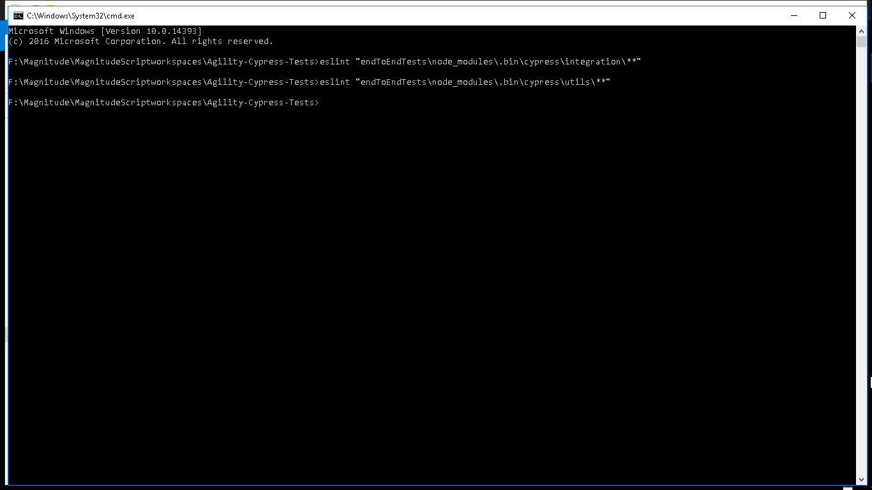

# Known Bugs and Limitations

## General Note

This section lists the known issues already observed.

## Defect of Bug

1)AMI: 1930:75 - In workspace dropdown, Create New Work Space option is still visible after un checking “can edit” workspace check box. As per test case, expected behavior is that it shouldn’t be visible.

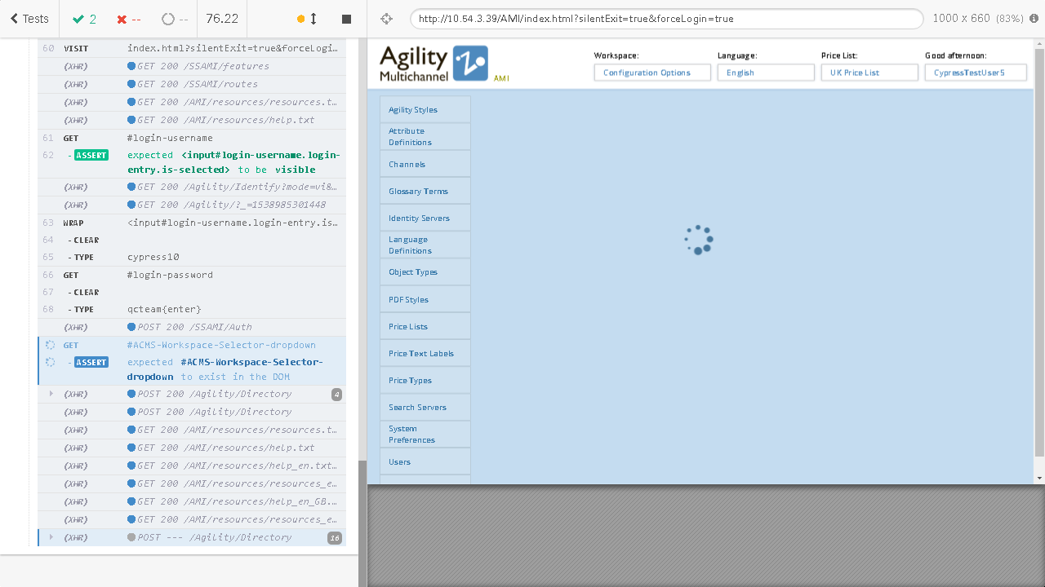

2)Application is taking too long time to respond at places where page refresh is done. There to handle the behavior, time out function(wait) have been used.